Henry Williams was pleased to once again be invited, and to attend Parker Hannifin’s Annual Preferred Supplier day. It is a great opportunity for Parker’s to share their vision, aspirations, and targets for the year ahead, in a relaxed atmosphere with their chosen stakeholders. It is also a time for renewing acquaintanceships and relationships outside of the normal working environment, and a great day out.
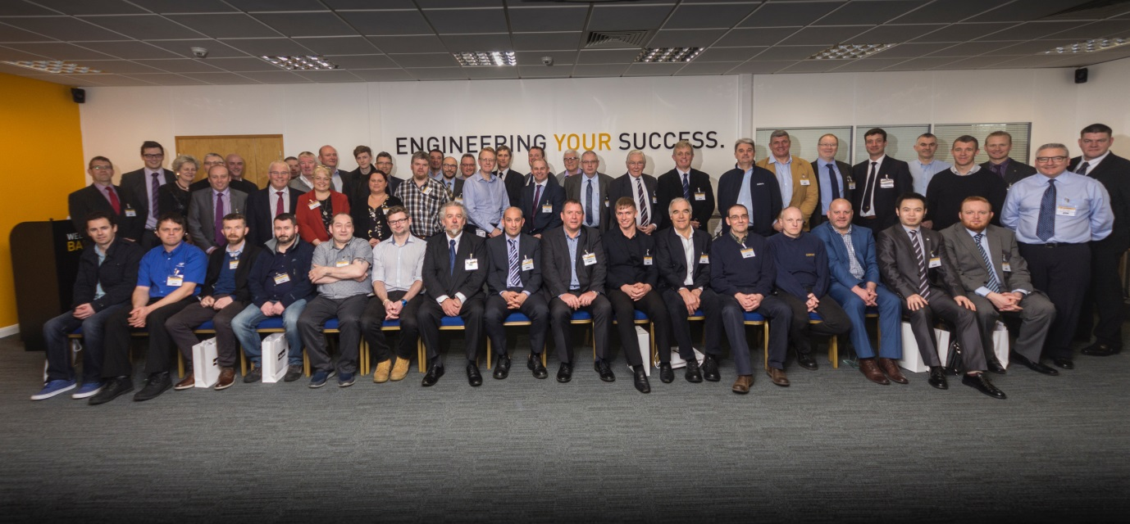

Henry Williams are proud to be an approved supplier of Forgings to Parker and of our long standing association with them. We are also gratified to think that our forgings become key components in the many and diverse industries that Parker operates in, and that enhance our day to day living such as fuel, food and drink.

Andrew Nelson our MD and Mike Wilson Business Development Manager Oil and Gas, represented Henry Williams at the Event.

Andrew can be seen here in the photo accepting our preferred supplier award from Andrew Spivey, Divison General Manager - IPDE.
